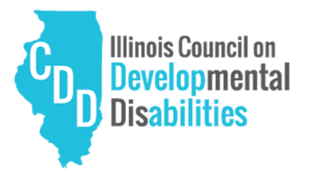

ACTION MANUAL
  - CARES
Community Action for Referenda to Ensure Stability
In partnership with:
Table of Contents
CARES BACKROUND 2
Who is it for? 2
Why is it needed? 2
What does CARES do? 3
How can CARES help my community? 3
Why is this needed now? 4
Process 5
Flow Chart 5
What does a 377 Board Provide? 5
What happens when a 377 Board is established? 6
How much does it cost? 6
Building a Coalition 7
Creating an Identity 7
Finding Likeminded Organizations 8
Tell Your Story 8
Consider a Budget 9
Determining the Best Path 10
Referendum Question 11
Path 1: Board Route 11
Path 2: Petition Route 12
Petition Gathering Steps 12
Getting on the Ballot (Petitions) 15
How Much Does It Cost? 20
Sample News Release 21
FAQ 22

Community Action for Referenda to Ensure Stability (CARES) Background

WHO IS IT FOR?
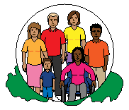
- Over 50,000 children and adults in Illinois have intellectual and developmental disabilities who are awaiting Medicaid-funded services. In addition, another 28,000 children who are currently in Special Education programs will require adult level services within the next ten years.

WhY IS IT NEEDED?
- Less than 8,000 people have been selected from the current waiting list for Medicaid services over the last ten years.
- Many of the people and families of those with intellectual disabilities are facing dire situations as they wait for the resources that are so badly needed.
- Unfortunately, services in many communities are the victims of budget cuts. Local resources are often inconsistent or unstable, leaving a lack of resources when it comes to funding worthwhile community programs.
- Revenue that is raised from a community - stays in that community.
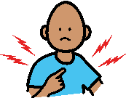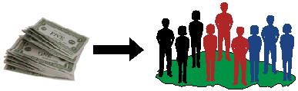

WHAT DOES CARES DO?
- CARES will educate and empower local communities to obtain the reliable funding they need to make sure those who need it most are not left behind.

HOW CAN CARES HELP MY COMMUNITY?
- CARES will assist those communities across Illinois who seek to have a reliable, local source of funding for programs benefitting those with physical, developmental, intellectual, and mental health challenges.
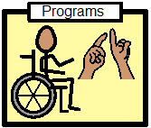

- CARES will train activists for their respective communities to obtain funding through local referenda ensuring those localities will be able to provide for those individuals, enabling them to live with dignity and purpose.

WHY IS THIS NEEDED NOW?
- As of July 7, 2020, 56,948 Illinoisans with developmental disabilities are on a statewide waitlist (PUNS), while thousands of those are actively seeking services.

- At the current time, many of those on the waitlist have a 7 to 8 year wait on receiving services that range from assisted transportation to occupational and behavioral therapy.

Process

What Does a 377 Board Do?
A 377 Board ensures local control and resources to be invested in services for the developmentally disabled, allowing for greater flexibility and cost savings over alternate methods. A 377 Board has been possible at the county level but since legislation was passed in 2018 (P.A.100-1129), a 377 Board can be established at the township or municipal level, making it possible to access local resources.

What Happens When a 377 Board is Established?
- A 377 Board can be established via referendum at the county, township or municipal level
- A three-person board is created, appointed by the head of the County Board or the Township Supervisor or Mayor, to administer this act
- The governmental unit that collects the tax as levied is the County Clerk or Township which collects and distributes the funds to the local board.
  - county or township, as the case may be, shall pay to such city, village, incorporated town, or township, as the case may be, the entire amount collected from taxes under this Section on property subject to a tax which any city, village, incorporated town, or township thereof levies to provide community mental health facilities and services.
- The Board then appropriates and oversees the funding for necessary services.

How Much Does It Cost?
- The cost is capped at 0.01% of assessed property value.
- For example, a home with a value of $100,000 would have a maximum cost of $2.75 per month or $33 per year.
- A home with a value of $300,000 would have a maximum cost of $8.33 per month or $100 per year.

Building a Coalition
While there are many ways to start a coalition to support your new effort, focus on the basics to get it off the ground.

STEP 1: Create an identity for your movement. This may include something as simple as devising a name for your organization (ex. Smith County Cares, Jonesville Citizens for Funding Fairness, or LIFT – Lifting Individuals for Thomas County). Make sure that your name represents community, fairness, and a common effort that people from all walks of life can rally around. Stay away from anything that can be construed as offensive or divisive.

TIP: Finding others who can tell their story, either through printed materials, at community meetings or by going door to door, can reinforce the badly needed funding that the referendum will generate.

STEP 2: Find like-minded individuals and organizations. This is a group effort! It may be as simple as talking to others who may already receive, or are waiting to receive services, for the developmentally disabled. You can also speak with neighbors, friends, workplace colleagues and school organization members to share your story (and/or the stories of your fellow activists) to stress how important funding fairness is in your community.
Many Illinoisans can identify with reduced or eliminated services due to years of inadequate funding at the state level. By introducing your effort in combination with the state’s fiscal deficits, your movement will become quickly relatable to many in your community.
When it comes to finding other organizations that can help, like-minded groups focused on mental health, counseling, and the developmentally disabled are easy to bring into the conversation. Groups outside of the disability sphere can include the League of Women Voters, Police and Fire (First Responder) organizations, local funeral homes, and even service organizations like the Lions Club and Knights of Columbus.
STEP 3: Tell your story. The resources provided as part of CARES will give you all the facts you need to share with your community. Statistics such as financial need, number of people waiting for services, length of wait, cost savings and annual rates are all available on the CARES website for you to access. A one-page example with general statewide information, along with other resources, are (or will be) available for download.

STEP 4: Consider a budget for your endeavor.
How much will it cost to get the word out? Think about a realistic budget for your campaign. Consider printed materials to distribute and yard signs or bumper stickers to gain visibility.
With the facts in hand, it is time to get your community on board!

Determining the Best Path

Referendum Ballot Question:
“Shall (governmental unit) levy an annual tax not to exceed 0.1% upon the equalized assessed value of all taxable property in (governmental unit) for the purposes of establishing and maintaining facilities or services for the benefit of its residents who are persons with intellectual or developmental disabilities and who are not eligible to participate in any program provided under Article ILCS 5/14-1.01 et seq., including contracting for those facilities or services with any privately or publicly operated entity that provides those facilities or services in or out of (governmental unit)?”
TIP: If you have fellow activists as part of your effort who live outside of your district, have them contact their respective board member to request a meeting as well. Encourage your friends and neighbors to contact county board members as well through phone and email to emphasize the urgency for this effort. Attend townhall and public meetings to participate in the democratic process. Make sure to have plenty of information at hand to educate!

Path 1: Board Route
There are two ways to initiate a referendum and create a 377 Board for your community. The first is by having the referendum question placed on the ballot by the county board, township, or municipality where you are seeking to hold the referendum. The county, township or municipal board can introduce the referendum question for a vote during one of their meetings, and if successful, have it placed on the ballot in the next election.
To initiate this process, contact the County Board member, Township Trustee or in municipalities they may be an Alderman or Trustee for your respective district and request a meeting. Make sure to be well versed on the major points of a 377 Board, why it is so badly needed. It would also be helpful to cite examples of other Counties, Townships, or communities (especially if they border yours) that have adopted 377 boards.
Keep in mind that board members have many constituent groups and coalitions that they must represent.
TIP: Remember, it is crucial to have a qualified attorney create and/or review your signature petitions before turning them in to your local election authority. Petitions that are incorrect can be rejected, if challenged by an outside party. Contact information follows later on in this document.

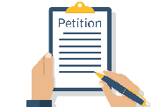 Path 2: Petition Route
The second way to place the referendum question on the ballot is through the petition process. The petition process is a way to hold a referendum by having registered voters in the community express their desire to do so. While this method is a little more complicated and time consuming, it has additional benefits by informing voters (when they sign the petition) about the referendum and how it will help your community.

Petition Gathering Steps
- Recruit a core group of volunteers, sometimes you can start with just 3-4 people.

- Obtain a list of registered voters in your area. This can be obtained from your county election authority for a small fee. CARES can also provide a contact that can provide a custom list for a specific area.

- Organize petition gathering drives at regular intervals – Weekends usually work best, since more people are home. Make sure to approach people at appropriate times – after 10:00AM on Saturdays and after 12:00PM on Sundays. Do not go out after dark.

- Make sure you have enough clipboards, pens, petitions and educational material to share with people when you ask them to sign the petition.

- What should you say? Try: “Hi, I’m your neighbor, John. I’m working with others in our community to bring some crucially needed funding fairness to those with disabilities in our area. Would you be willing to sign our petition to help get a referendum question on the ballot?” IF YES: Thank you so much, we greatly appreciate your help. IF NO: Thank you for your consideration and we hope that you will take this handout in order to learn more about what we’re doing.
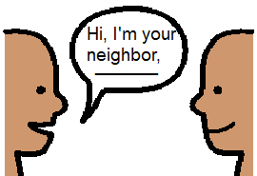

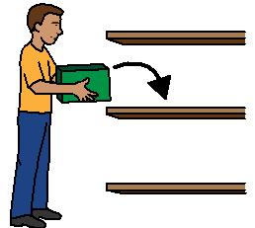
- Make sure to collect all petitions and store them in a safe place. Additional instructions for signers and circulators follow on the next page.

- Make copies of your petitions to use later on, when contacting voters before election day.
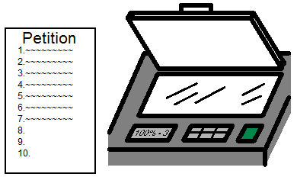

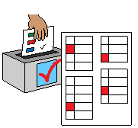 Getting on the Ballot (Petitions)
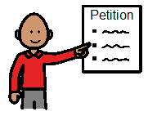 Circulator Instructions
- Circulators MUST be 18 years old (or 17 years old and eligible to vote in Illinois) and a citizen of the United States. You do not need to live in Illinois (unless you are 17 years old). You do not need to be registered to vote.
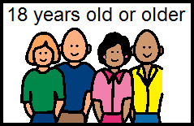

- Only one person is allowed to circulate each page of a petition.
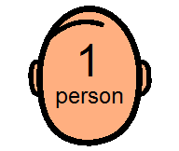
- Ask each person signing the petition if they are registered to vote in the County, Township or Village or City that the referendum is taking place.
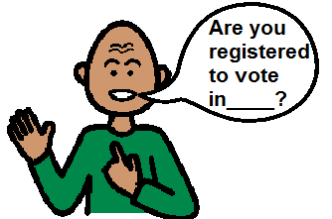

- Circulators MUST see the person sign the petition. Never leave a petition unattended, such as on a counter or with someone else.

- Circulators MUST personally appear and sign the circulator’s oath and a notary seal stamped on the petition by a notary public licensed in Illinois. Most banks and public libraries will notarize a petition free of charge. Currency Exchanges have a notary available for a small fee.

- Petitions with fewer than ten (10) voter signatures DO count. If you are not able to fill the petition, you should still send in the partially filled petition. Each signature counts towards the required amount.
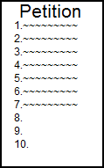

- Circulators MAY sign the petition they are circulating if they are registered to vote in the county holding the referendum.

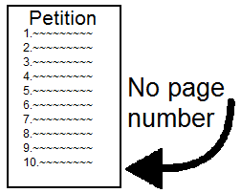
- Blank spaces in the circulator’s affidavit SHOULD be completed with the exception of the page number.
DO NOT NUMBER THE PETITION SHEETS.

Signer Instructions
- Signers must live and be registered to vote in the County, Township or City in which the referendum is being held. Write your Rural Route number if you do not have a street address.

- Petition signers do not need to have voted in a previous Primary to be eligible to sign the petition.
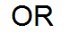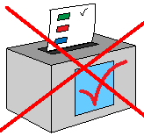

- All petition signers MUST sign in the presence of the circulator.

- Petition signers may NOT sign the petition more than once.

- Petition signers MUST sign only for themselves. They MAY NOT sign for spouses, family members or others.

- Petition signers SHOULD sign their names as listed on their voter’s registration card. For example, “William E. Jones” not “Bill Jones”.
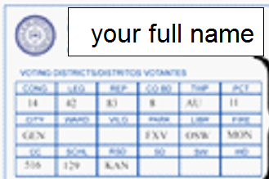

- The petition signers SHOULD SIGN AND NOT PRINT THEIR NAMES unless that is the way they signed their voter’s registration card.
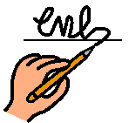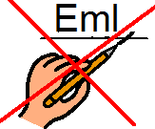

- DO NOT use ditto (“ ”) marks for any part of an address.
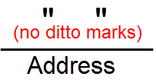

REMEMBER: Petitions are legal documents. As such, it is always important to have a qualified election attorney prepare, review and bind your petitions for submission. In addition, should anyone review and challenge the submitted petitions, an election attorney can help defend against the challenge in order to keep the question on the ballot.
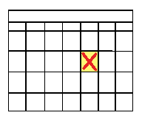PETITION CIRCULATION PERIOD: There is a legally prescribed window in which to circulate petitions for signature, as well as a set turn-in period. Petitions circulated outside this time frame or after the turn-in deadline will not count. Deadlines and guidelines will be added when they are officially established.
The offices and locations for submission will be added in a separate document.

How Much Does It Cost?
First and most importantly – You and your neighbors get to choose.
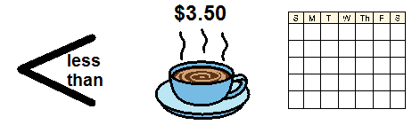For less than the price of a latte at $3.50, per month, you can be sure that your money stays in the community and provides critical services for people with intellectual or developmental disabilities.
At a maximum of .010% of assessed valuation:
- a home with Market Value of $100,000 - maximum cost per household: $33 per year
- a home with Market Value of $300,000 - maximum cost per household: $100 per year
Keep YOUR tax dollars at home and invested in local programs and services, helping to provide resources for your neighbors. When revenue sources have been reduced and priorities expanded, you can be sure that these programs and services are protected, and cost-effective solutions are found here at home.
To get your local assessed valuation of property in your county, township or municipality, to best determine the cost to local taxpayers, you can talk to the County Clerk’s office for the details. They can provide you with a list of average assessed value of properties in the area you request. These are public records and you can ask for this assistance.
During our CARES training, we will provide you with contact information for local resources.

SAMPLE NEWS RELEASE
FREQUENTLY ASKED QUESTIONS (FAQ)
FOR IMMEDIATE RELEASE
CONTACT: JANE SMITH (217) XXX-XXXX
JULY 1, 20XX
LOCAL COMMUNITY GROUP STARTS FUNDING INITIATIVE FOR DEVELOPMENTAL DISABILITIES
Will Aim to Bring Funding Fairness for Crucially Needed Services
XXXXXXX, IL – With funding for intellectual and developmental disabilities increasingly scarce, local citizens have come together to form a new group, promoting a ballot referendum to ensure that crucial resources will be there in the future.
Currently, over 50,000 children and adults in Illinois are waiting for Medicaid-funded services and over 28,000 children currently in Special Education programs, will require adult services over the next ten years. Over the past decade, only 8,000 people have been selected from a waiting list, with the majority facing a 7-8 year wait, if they are even selected at all.
“With the constant strain on state and local budgets in Illinois, many people in our community are needlessly being left behind,” said Jane Smith, Chair of the Funding Fairness in Our Community Coalition. “For as little as $2.75 per month, per household, we can keep these funds in our community to provide crucial support for those who need it most.”
The funding fairness referendum, to be placed on the ballot this spring, will ask voters to authorize a levy of XX%, or a total cost of $33 per year.
“Now, more than ever, we need to help friends and neighbors in our community to bring reliable and sustainable services to our community,” added Smith. “It would be a shame to pass up this opportunity to provide a fair playing field for all of our residents.”

When should we start our ballot referendum campaign?

As soon as possible. State law mandates a prescribed time for petition circulation and referenda to be placed on the ballot. For statewide (even year) elections, the petition circulation period generally commences during the first week of September (you may not start before) and concludes during the last week of November. More information can be found at the Illinois State Board of Elections website (www.elections.il.gov). However, it is always helpful to get a head start before you can legally start to circulate petitions. This includes volunteer recruitment, deciding on your messaging, and building your coalition.

Do we need to file with the Illinois State Board of Elections?

Maybe. Depending on the type of action you are taking, you may need to file with the Illinois State Board of Elections. This would include if you are forming a committee to raise and expend funds specifically for a referendum or if you raise or spend $5,000 on behalf of the referendum campaign. You should seek the guidance of a qualified election attorney.

How many signatures do we need to get on the ballot?

Each jurisdiction has a different number of signatures needed, based on the top vote getter in the previous election. A document with the required number of signatures for your area can be found on the CARES website.

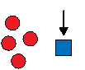If I don’t have time or enough volunteers to get signatures, what are my alternatives?

While getting signatures (especially door-to-door) can be challenging, you can use other methods to gather signatures. Farmers markets, libraries, train stations and high school football games are all ways to find petition signers quickly. Always make sure you are respectful of the location of your signature gathering. Many retail stores frown upon petition gathering. Always ask a manager or a person in charge before starting.

Who is 377 Funding for and what can it be used for?

377 funding is generally used to fund services for individuals that are not funded or covered by Medicaid. With Medicaid funding delayed and/or harder to come by in Illinois, 377 funding can help bridge the gap and help support services in innovative ways. Outside of traditional services, some 377 funds have been used to fund innovative programs across the state. Several areas use 377 funds to help support those who do not fit under common criteria for services or to best tailor programs to people’s needs. For example, funding has been used to support social opportunities for those with disabilities, as well as help with family support services. Other 377 Boards have used funding to screen children from 0-3 years old who the state does not currently support. There are a multitude of ways that 377 funding can help those in your community.

What if I need more information on statistics or other information regarding the referendum?

Check the CARES website, as it will be updated to include new information, as it becomes available.

Whom should I contact if I need help with design services, social media, election attorney referrals or help with news media?

You can contact Stephen Rossi with Fortis Strategies at srossi@fortisstrategies.com.

Produced with the assistance of
Association for Individual Development (AID) -
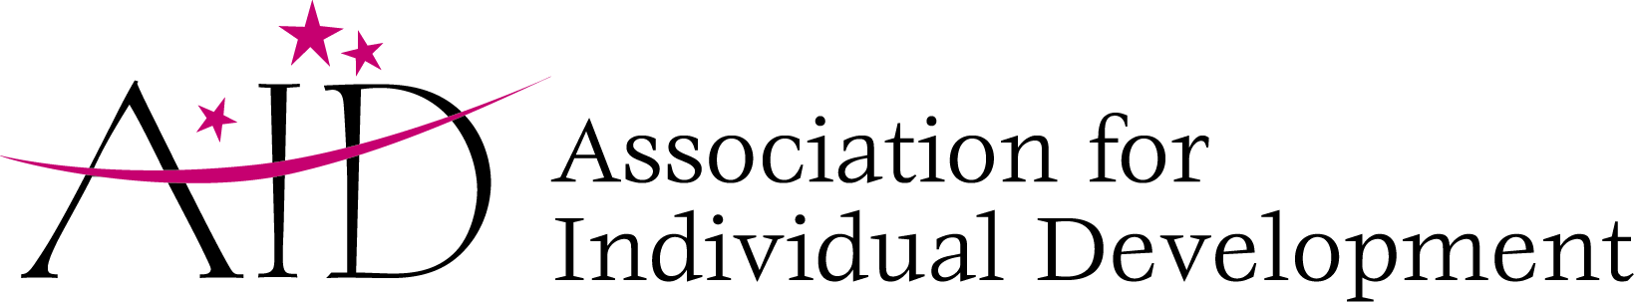
CARES (COMMUNITY ACTION FOR REFERENDA TO ENSURE STABILITIY) ACTION MANUAL
In partnership with the Illinois Council on Developmental Disabilities. This project was supported, in part by grant numbers 19/2001ILSCDD-02, from the U.S. Administration for Community Living, Department of Health and Human Services, Washington, D.C. 20201. Grantees undertaking projects with government sponsorship are encouraged to express freely their findings and conclusions. Points of view or opinions do not, therefore, necessarily represent official ACL policy.

